# Manufacturing processes



**THE MORGAN**

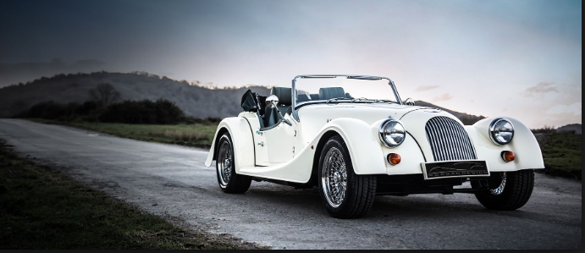

**Exercise 1.**

**Watch the video and answer** Click [***here***](https://drive.google.com/file/d/1iSU8WKoQY0R2pFqQZ2HEzznmvWQpLgv2/view?usp=sharing)

1. What sort of cars did the factory make at the beginning?
2. Why are four-fours called so?
3. What is the factory weekly output?
4. Do they make the engines?
5. What is the meaning of “built to order”?
6. What is Morgan’s best knwon car?
7. What does the presenter say about the order books?

**Choose the correct option**

1. Morgan first became famous because of its *car racing / modernity*

2. Morgan is different to other car companies because the cars are made by *machines / people*

3. Most of Morgan’s staff come from *all over the world / the surrounding area*

4. The customer orders a car *after / before* it is made

5. The company is most widely recognized for the *Aero 8 / Roadster*

6. It’s rare to find *person-made / hand-made* cars- they are usually made by machines

7. The process in other companies is completely *automated / machined*

8. All of our cars are built to *demand/ order*

9. Our *output / process* is low – only 50 cars a month – but the quality is exceptional.

10. We *put / place* them together once we have received an order.

**The story of cork**

**Exercise 2.**

1. Read the texto below and answer:

1. Where does cork come from?

2. What is the most important product made from cork?

3. Which country is the world’s biggest producer of cork?

4. Why does NASA use cork in ocket engines?

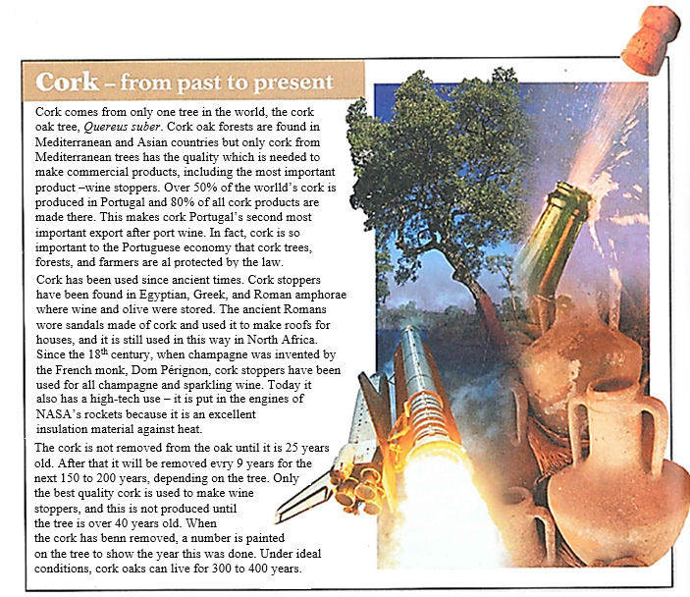2. Underline all the examples of verbs in the passive voice and identify their tenses: *Present Simple, Past Simple, Present Perfect, Future*

**The passive voice\***

|  |  |
| --- | --- |
| **Present Simple**   * Cork oak forests **are found** in Mediterranean and Asian countries. * The cork **is not removed** from the oak until it is 25 years old. | Facts, habits. |
| **Past Simple**   * Champagne **was invented** by the French monk, Dom Pérignon. * Wine and olive oil were stored in Egyptian, Greek, and Roman amphorae. | Finished actions in the past, with definite time. |
| **Present Perfect**   * Cork **has been used** since ancient times. * Cork stoppers **have been found** in Egyptian, Greek, and Roman amphorae. | Past actions that continue to the present.  Past actions with no definite time.  (Only time expressions with **“since”** and **“for”** can be used. |
| **Future**   * The cork **will be removed** every 9 years for the next 150 to 200 years. | Future actions |

**\* *The Passive Voice*** is used when the action is important (not the person carrying it out) or when the person is unknown.

The verb **“to be”** determines the tense (present, past, present perfect, future, etc.)

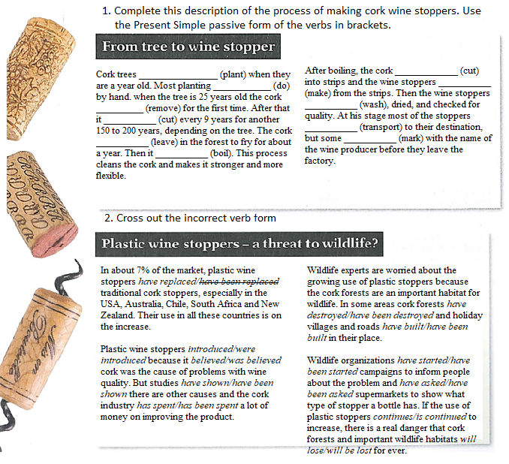**Exercise 3.**

**Exercise 4.**

1. Complete the following list of facts about coffee using the correct tense in the passive voice.

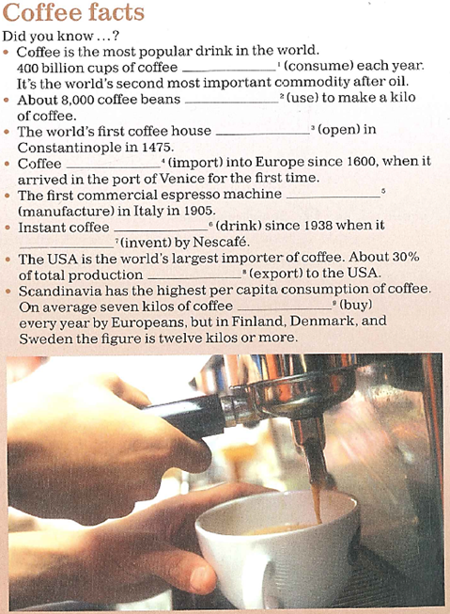

**Describing a process**

**Exercise 5.**

Click [***here***](https://drive.google.com/file/d/1QBkg5N56-UDoM6TQd6tnrnAj5xg2hVP3/view?usp=sharing)to listen 10.7.

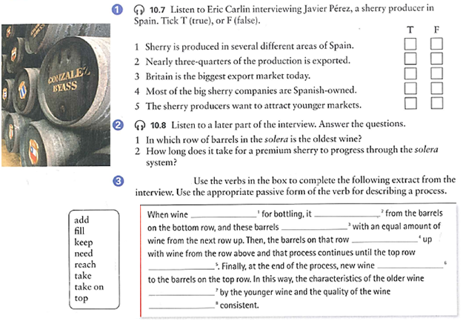Click [***here***](https://drive.google.com/file/d/1XAdFip5U4l-moc8kKkJhaHjqYC2qPDE3/view?usp=sharing) to listen 10.8.

**Exercise 6.**

Number the stages below to show the correct order in which olive oil is made. Then write the sentences in the passive.

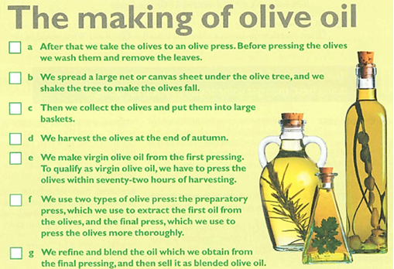

**Exercise 7.**

**Active or passive?** Write the correct form of the verbs between brackets.

**Denim: from cotton to a pair of jeans.**

**1)**  Bales of carefully selected cotton ………………………………… *(arrive)* at the denim mill. In the opening stage, baled cotton fibre ………………………………… *(separate)*into small tufts. Different varieties of cotton can ………………………………… *(blend)* together to produce optimal yarn strength.

**2)** Next, the cotton ………………………………… *(turn)* into a web of fibres which then ………………………………… *(go)* through a process known as carding where short fibres, sticks, leaves and any other dirt ………………………………… *(remove)*. The “cards” also ………………………………… *(convert)* the web into a rope-like form called sliver.

**3)** The drawing process ………………………………… *(produce)* a single, uniform silver from six silvers. This silver ………………………………… *(draw)* out into a thinner yarn. Then, these ropes ………………………………… *(put)* on spinningmachines that ………………………………… *(twist)* and ………………………………… *(stretch)* the fibres to make yarn.

**4)** Large balls of yarn, call ball warps, ………………………………… *(dip)* into an indigo mixture several times. Next, in the beaming process, the dyed rope ………………………………… *(separate)* into individual warp yarns which ………………… then ……………… *(coat)* in starchy substances to make the threads stronger and stiffer.

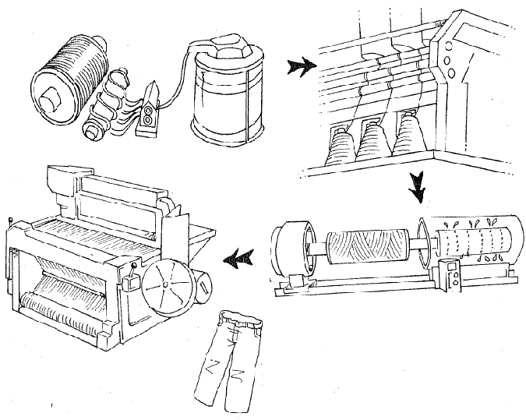**5)** The yarns ………………… finally ……………… *(weave)*, interlacing the warp -long, vertical blue dyed threads- with the weft –shorter, horizontal white threads- on a large mechanical looms. The denim ………………………………… *(be)* ready for finishing, a term referring to a variety of treatments applied to the cloth like brushing, singeing – burning off stray fibres with a flame- and skewing –used to prevent it from twisting when it ………………………………… *(make)* into clothing. The finished cloth ………………………………… *(be)* now ready to ………………………………… *(roll)* and finally ………………………………… *(sew) for clothing manufacture.*

**Exercise 8.**

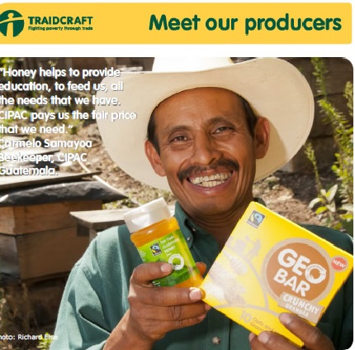****

**Video “TRAIDCRAFT”** Click [***here***](https://drive.google.com/file/d/1--acU2vtCM7RYTh1spdhPPu2nQlvCrYR/view?usp=sharing)

1) **Mention 3 developing countries and 3 developed countries**.

2) **Match each word with its definition:**

1. fair a. *Cultivated plants or agricultural produce, such as grain, vegetables, or fruit*

2. trade b. *Just; equitable.*

3. crop c. *bluish berries which can be eaten*.

4. blueberries d. *The business of buying and selling commodities; commerce*.

3) **Watch the video about Traidcraft and answer the following questions:**

a) Where are the developing countries mentioned situated?

b) Crops mentioned which are grown in these regions.

c) 3 problems the population in these regions have:

1)

2)

3)

d) How many honey producers belong to APICOOP?

e) How are Valdivia and Gatehead related through Traidcraft?

f) Mention 3 ingredients in GEOBAR and their origin.

………………………………..from ……………………………

………………………………..from…………………………….

………………………………..from…………………………….

g) What is the money from Geobar sales used to buy for?

4**) Complete the following sentences in PASSIVE VOICE**:

1) Honey …………………………………(produce) in Valdivia.

2) Traidcraft products …………………………..(sell) in the UK.

3) Goods from the developing world …………………………(buy) by Traidcraft.

4) Fairtrade ……………………………..(establish) in 1992.

5) A fair price …………………………(pay) for the products.

6) This crop ………………………..(grow) in Southeast Asia.

**Exercise 9.**

1. Listen to a project manager describing the process of developing a new car. Number the photos in the right order. Click [***here***](https://drive.google.com/file/d/1Tm9npKMEuRUNc8Zl61IIU3HQ8XvdsYKO/view?usp=sharing)

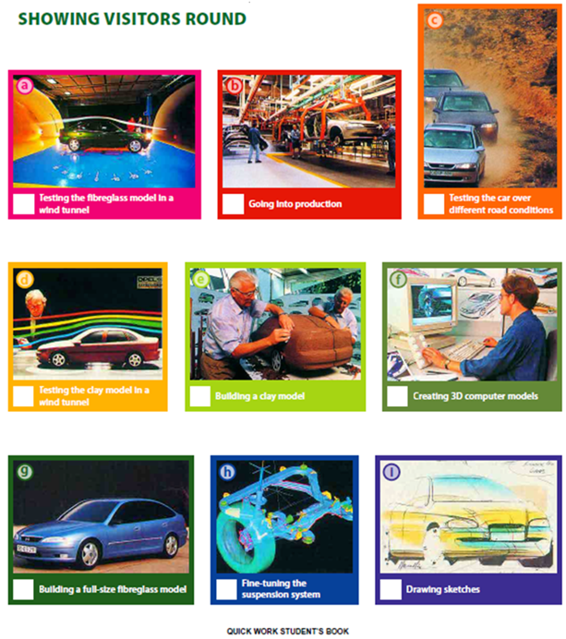

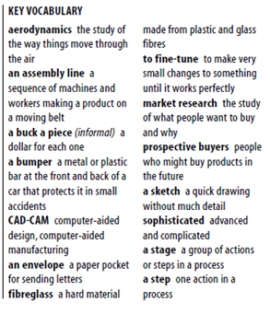2. Listen again and answer these questions:

a. What kinds of calculations are made by the computers?

b. Why is clay used to make the first model?

c. Who is the fibreglass model shown to?

d. What else is the fibreglass model used for?

e. Where are the real cars tested and why?

f. How are the cars built?

3. Listen to the phrases the manager uses to explain the sequence of the actions in the process. Complete these sentences.

a. ………… ………… ………… a basic idea – a few sketches on the back of an envelope.

b. ………… ………… ………… is to make a clay model of the car.

c. …………, ………… …………, we build a fibreglass model.

d. It’s too late to make major changes to the design ………… ………… ………… .

e. Yes, production’s ………… ………… ………… .

4. Summarize the stages of the process using the passive voice.

**LISTENING** **SCRIPTS**

**10.7 International Express (intermediate)**

**E: Eric, JP: Javier Pérez**

**E:** Well, first, Señor Pérez, thank you for welcoming us here today to your *bodega* to talk about the production of sherry. Could I start by asking you about the area of production? Is sherry produced oonly in this area of Spain?

**JP:** Yes, That’s right. It’s produced in the area formed by the sherry towns – that’s Jerez de la Frontera, El Puerto de Santa María and Sanlúcar de Barrameda

**E:** So, all sherry come from this area?

**JP:** Yes. Since a European Union las in 1966, only wines from this area, which is called “the classified sherry zone”, can be called sherry. Wines from other areas, or other countries can’t be called “sherry” because it’s a protected name, like *champagne* in France.

**E:** Yes, I understand. Now, I imagine a lot of the sherry that’s produced is exported –is that the case?

**JP:** Oh, yes, certainly. Today about 70% of total production is exported. And in fact exports of sherry represent a quarter of all Sanish DO wine exports.

**E:** Er… by “DO wine” do you mean wine produced in classified areas?

**JP:** Yes, in Spanish it’s *Denominación de origen*, it’s like *appellation controlee* in French, so yes, wine from an area where quality is controlled.

**E:** I see. Thank you. And which countries are your main export markets?

**JP:** Historically, Britain has always been our most important export market but today Holland is our number one export market, with Britain next, and Germany third. They’re our three big markets. Then come the USA, other European countries, and Canada.

**E:** So, if 60% of sherry is exported, then only 30% is actually drunk in Spain?

**JP:** Yes, That’s right. And Spanish tastes are different. In Spain we prefer the dry, lighter sherries, whereas the export markets prefer the medium and sweet sherries, although tastes are beginning to change.

**E:** You say tastes are beginning to change. Could you explain in what way?

**JP:** Well, a lot of changes have taken place in the sherry industry in the last decade or so. Most of the big sherry companies are now part of multinational drink groups, although there are still some Spanish-owned sherry producers. The traditional markets for sherry are in decline so we want to give sherry a more youthful image that wil attract the younger market. We’re promoting the dry, lighter sherries for this market, and it’s showing definite signs of work.

**10.8 International Express (intermediate)**

**E:** Could we talk about the final stage of production now? Earlier, on our tour of the *bodega* you referred to the *solera* system and said it was the system used for maturing the sherry and for maintaining a consistent quality. Could you describe how the *solera* system works?

**JP:** Yes, by all means. A *solera* is several rows of barrels, usually four or five rows. One on top of the other. In a *solera*, the pñdest wine is in the barrels at the bottom and the youngest wine is in the barrels at the top. When wine is needed for bottling, it’s taken from the barrels on the bottom row, and these barrels are filled with an equal amount of wine from the next row up. Then the barrels on that row are topped up with wine from the row above and that process continues until the top row is reached. Finally, at the end of the process, new wine is added to the barrels on the top row. In this way, the characteristics of the older wine are taken on by the younger wine and the quality of the wine is kept consistent.

**E:** And how long does it take for the wine on the top row to progress through the *solera* system?

**JP:** The minimum period is three years. For a good sherry it will be longer –five to six years, and for a premium sherry it’s likely to be eight years or longer.

**E:** Well, thank you very much, Señor Pérez. I’s been most interesting.

**JP:** It was my pleasure. Now you must come and try some of our sherries.

**2.3 Quick work**

A: It all starts with a basic idea –a few sketches on the back of an envelope.

B: Really?

A: Sure, well, kind of. We work the sketches up into a full-size drawing and then we move it over on to these computers.

B: Do you use CAD-CAM programs?

A: Yes. We have some very sophisticated computers here to create 3-D modles and what’s really great is they can make all kinds of early calculations, like how the car will perform in a crash.

B: I see. And what happens next.

A: The next step is to make a clay model of the car. Come over here, I’ll show you one…

B: Why do you use clay?

A: It’s easy to build up and take off, so we can experiment.

B: And you try to improve the aerodynamics?

A: Yes. Aerodynamics is the key thing. It has to cut through the air.

B: So these clay models aren’t life size?

A: No, they’re about one-fifth of the real size, but that’s big enough to test in a wind tunnel.

B: OK.

A: Then, after that, we build a fiberglass model and that’s full size.

B: I see. And do you show it to prospective buyers?

A: Yeah. We use the fiberglass model for market research, and we use it for more tests, too. We put it in a wind tunnel again. Come with me and I’ll show you… It’s too late to make major changes to the design by this stage. But we can improve things like mirrors, wheels, bumpers…

B: To improve the aerodynamics?

A: That’s right. We also work on the suspension system, fine-tunning it to make sure the car will be comfortable and hold the road well. Then after that, we produce a real car and test that.

B: Do you have a test track here?

A: No, we have one in Death Valley in California. We can test the car over different road conditions there.

B: Before it goes into production?

A: Yes, production’s the final stage.

B: And tell me, do you use a lot of robots on the assembly line?

A: Yeah, these days the cars are all built by robots. There are very few people on the assembly line and they’re usually checking quality.